UNIT V
Transient Analysis & Filters

- Derive the expression for the current in series RL circuit and RC circuit with DC excitation.
- Obtain the Transient Response in Series RL and RC circuit with Sinusoidal Excitation.
- Drive the expression for the current in series RL and RC circuits with source free and DC excitation.
- Write a note on initial conditions of basic circuit elements
- Explain classification and characteristics of filters?
- Distinguish between Band pass and Band elimination filters
- Explain the operation of constant k-type filter in T and П configurations
Tutorial

- For the given network the switch is closed at t=0 sec with zero current in the inductor, find i, di/dt, d²i/dt² at t=0^{+ .}
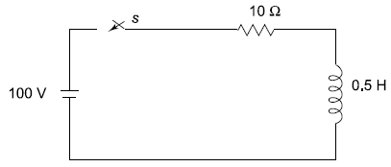
- Find time constant of below circuit, after closing the switch.
- In the circuit shown in the following figure , initially switch ‘K’ is kept open for long time. A t t=0 switch Kis closed obtain the expression for current in the circuit for t≥0. Find the value of current in the circuit in one time constant period ? Determine the instant of time at which the current in the circuit reaches to 1.2 A.
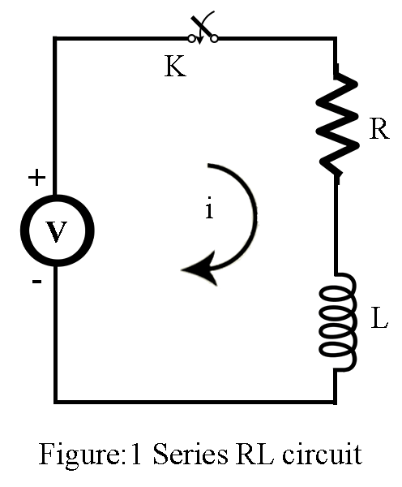
- In the circuit shown in figure 4. Initially switch k is kept at position A for long time .At t=0, switch is moved to position B .Find the expression for the current for t≥0.Find the value of current at t=6.6667msec, t=13.3334msec.Plot variation of current through inductor versus time.
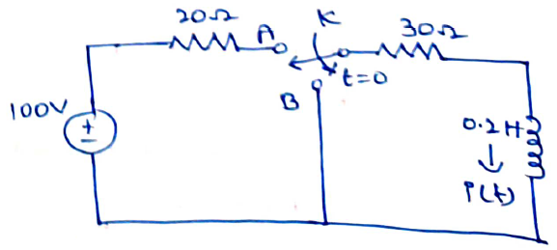

- For the circuit shown in figure 3, the switch is closed assuming all initial conditions zero. Find i, di/dt, and d²i/dt² at t=0⁺.
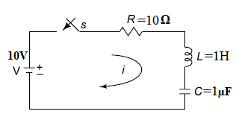
Figure 3

- Explain about Propagation constant and characteristic impedance in T-network filters.
- Explain about Propagation constant and characteristic impedance in Π-network filters.
- Design Low Pass Filter in both T& Π section having a cut off frequency of 2 KHz to operate with a terminated load resistance of 500 Ω.
- Design a High –pass filter having a cut-off frequency of 1 kHz with a load resistance of 600Ω.
- Design a Band-elimination filter having design impedance of 600Ω and cut-off frequencies
f ₁= 2kHz and f ₂= 6 kHz.
- Explain about Constant-K low-pass filter and Constant-K band -pass filter in detail.
- Short answer questions
- Expression for current in transient response of R, L, C combinational circuits with DC and AC excitations.
- Definitions and applications of Low pass, High Pass, Band Pass and Band elimination, Constant k-Type and m-type filters
- Distinguish between
- Band pass and band stop filters
- Low pass and High pass filters

